**Installing and using extraction plugin – instruction sheet**

Developed by: KTH-dESA

# GEP_OnSSET plugin

In order to facilitate the GIS-extraction the OnSSET team at KTH has developed a plugin. This brief document will go through

1. How to install the plugin
2. How to run the plugin

## 1. How to install the plugin

You will receive a zipped folder named gep_onsset from the shared google drive folder. Below follows the steps needed in order to get a functioning plugin.

1. Download the zipped folder onto your computer. Make sure that you know where it is saved
2. Open **QGIS Desktop 3.2.X with GRASS 7.4.X**
3. On top of the window you have a number of menus, click on the one that reads **Plugins.**

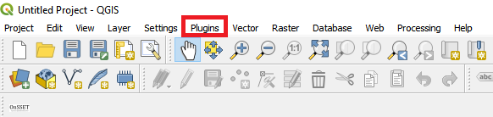

Figure 1. Plugin menu

1. Next, go to **Manage and Install Plugins…**

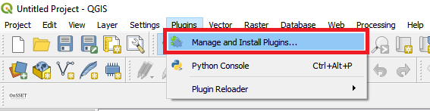

Figure 2. Mangaement menu for plugins

1. This will open a new window with a number of different options on the left-hand side. We will choose **Install from ZIP**

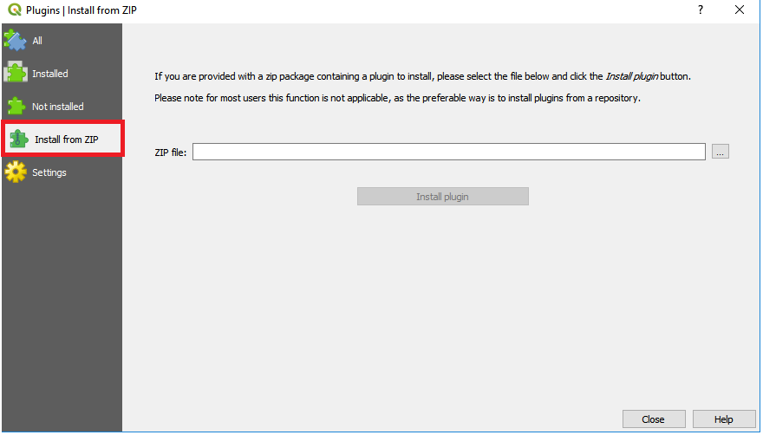

Figure 3. Installing plugins using ZIP-files

1. In the window that opens click on the three dots next to the empty field to navigate to wherever you saved the zipped file.

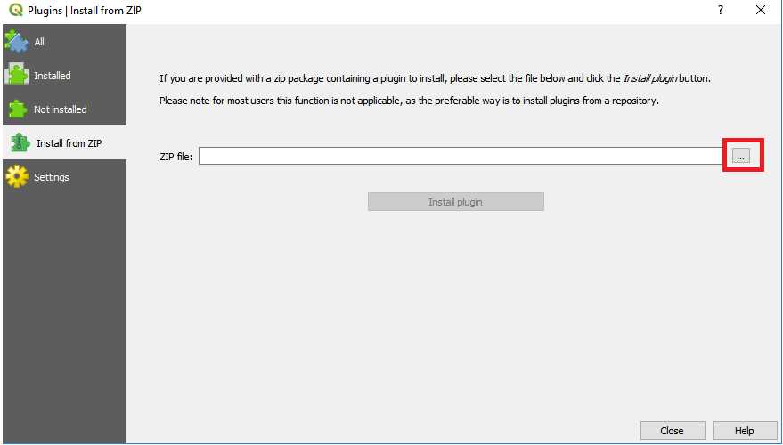

Figure 4. Click on this button to browse to the zipped file

1. When you have found it click **Install plugin**

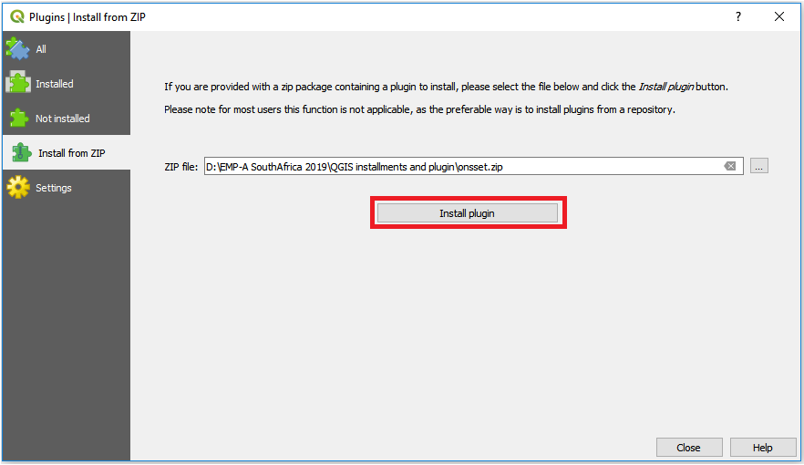

Figure 5. When you have found the zipped folder click on this button to install it

1. After the plugin has been installed will appear under the **Database** menu on top of the screen. You are now ready to run the plugin.

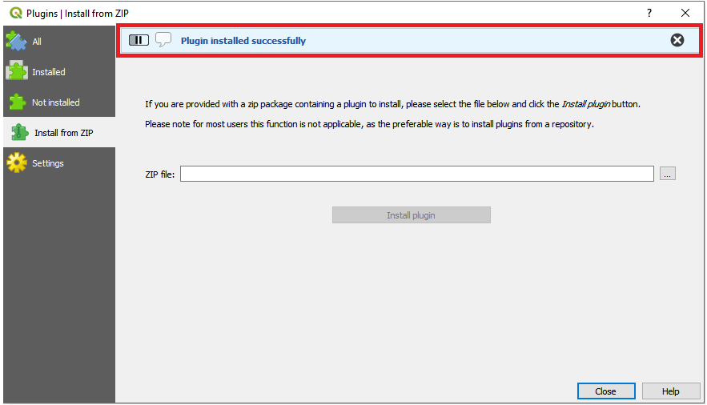

Figure 6. This field will appear when the install is completed

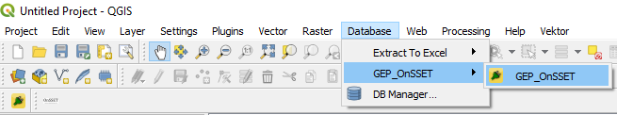

Figure 7. When the plugin is installed it will appear under the database menu with the name "GEP_OnSSETl"

## How to run the plugin

Before opening the plugin make sure that all the dataset that are needed to run it are loaded into your QGIS window. Make sure that all the datasets have the correct type. The datasets are the following:

Table 1. The datasets needed for the analysis. Their names are not important but the type is cruicial.

|  |  |
| --- | --- |
| Dataset | Type |
| Administrative boundaries | Polygon |
| Population | Polygon |
| GHI | Raster |
| Wind speed | Raster |
| Travel hours | Raster |
| Nighttime lights | Raster |
| Elevation | Raster |
| Land cover | Raster |
| Existing HV transmission lines | Lines |
| Planned HV transmission lines | Lines |
| Existing MV transmission lines | Lines |
| Planned MV transmission lines | Lines |
| Substations | Points |
| Transformers | Points |
| Roads | Lines |
| Hydropower | Points |

**NOTE: The name of the datasets are arbitrary. If you are missing a specific dataset e.g. MV transmission lines replace it with some other line data and remove it manually later.**

**NOTE2: When you have made sure that you have all the datasets needed loaded into QGIS please create an empty folder (workspace) and name it after your country. This folder will serve as your workspace.**

**NOTE3: If you enter the wrong dataset in any of the boxes you might have to restart QGIS. To avoid this we will have to save the project as soon as all datasets are imported.**

1. **Open** the plugin from the **Database** menu. The name of the plugin when installed will be **GEP_OnSSET**
2. The following window will open up.

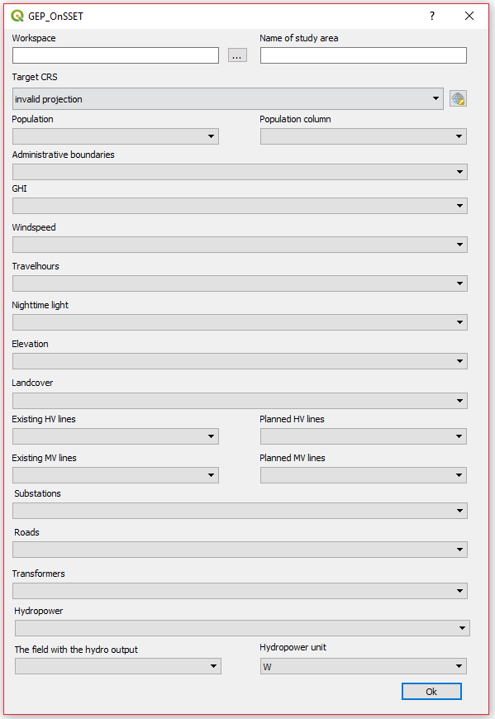

Figure 8. The plugin in use

Below information will follow regarding the use of each box

**Box 1**. This box lets you choose the workspace. Click on the three dots and navigate to the empty folder (workspace) that you created. When you have found it click ok and continue.

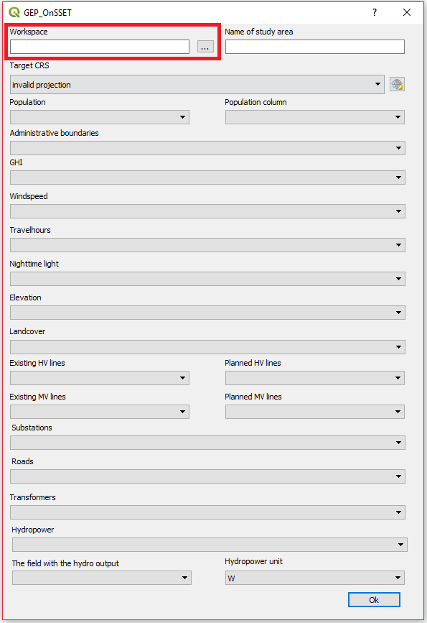

Figure 9. Box 1: enter the workspace by clicking on the button with three dots and navigate to the empty folder you are using as workspace

**Box 2**. Enter the name of your study area (country). This is the name that will appear on your csv output file.

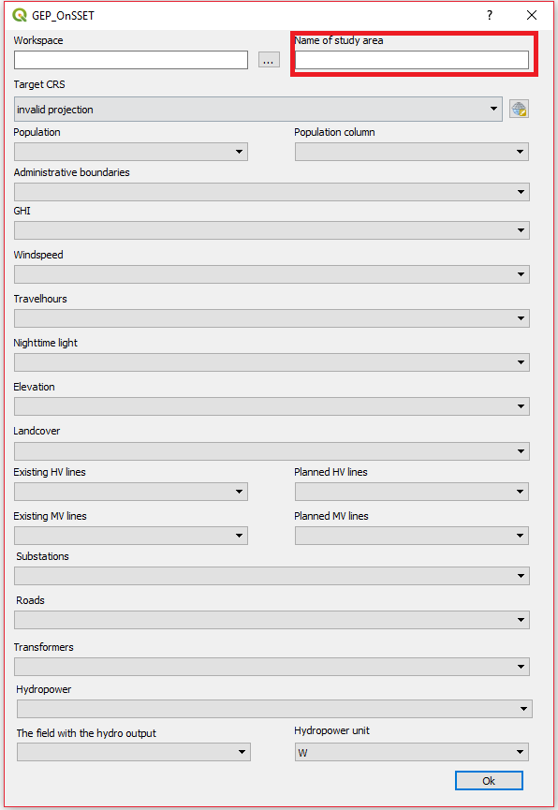

Figure 10. Box 2: enter the name of the study area,.

**Box 3**. This box lets you choose an appropriate coordinate system.

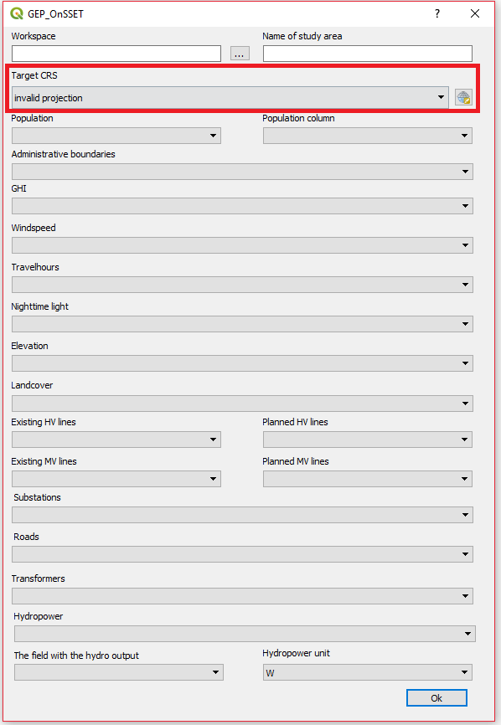

Figure 11. Box:2 choose the coordinate system that you want to reproject your data to.

To find the coordinate system that is appropriate for your country please visit <http://epsg.io/>, search for your country.

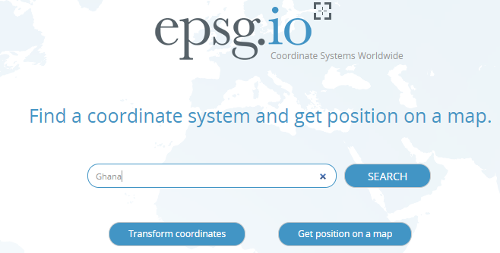

Figure 12. Go to epsg.io and search for the country you want to reproject

Next, come back to QGIS. Click on the icon next to the field and check the epsg codes received from the webpage. Choose one where the unit is in meters and the red box covers the whole area you are working with (Figurhänvisning).

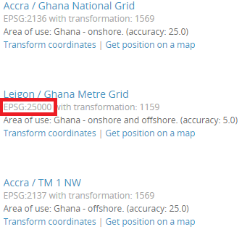

Figure 13. You will get a list of different coordunate systems that fit with your study area. Choose one.

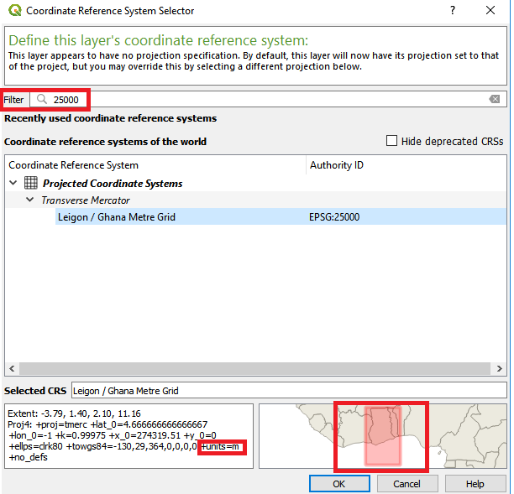

Figure 14. Enter the coordinate system you have chosen in the field. Make sure that the unit is meters (lower left box) and that the red area covers your study area (lower right box)

**Box 4 and 5**. In box 4 select the population dataset. In box 5 you will have to choose the column in the attribute table that includes the population values for each polygon.

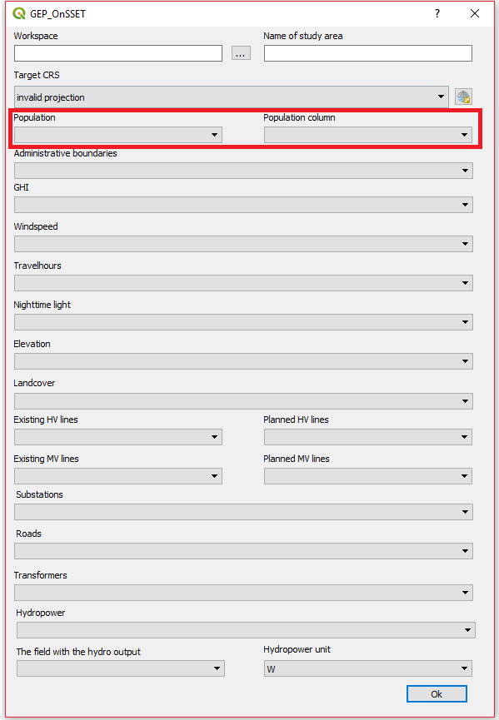

Figure 15. In the left box enter a population layer. If it is a point layer you will have to specify the population column in the right box.

**Box 6 – Box 20.** Select the correct dataset for the boxes

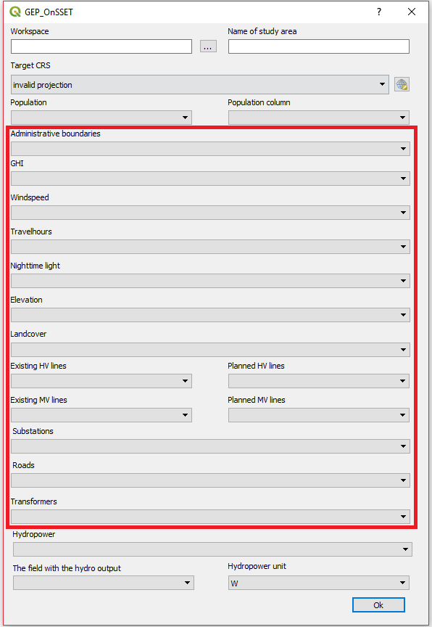

Figure 16. Fill in the correct datasets for each one of these boxes.

**Box 21.**  Click on the box and select the hydropower layer, make sure that it is a point vector.

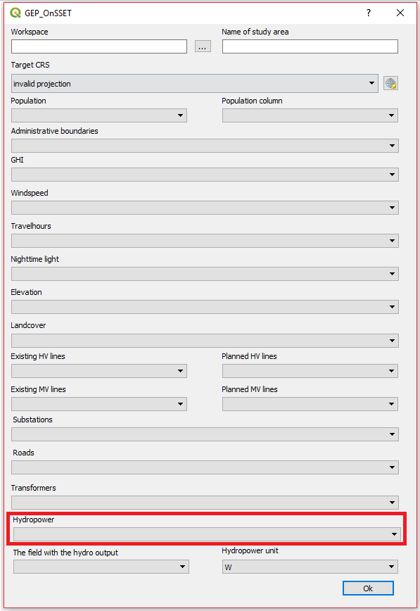

Figure 17. Hydropower points in this to be entered in this box

**Box 22.**  Select the box that includes the hydropower output (In this box you will select a column in the attribute table). The hydropower output is the potential electricity that can be outputted from each plant

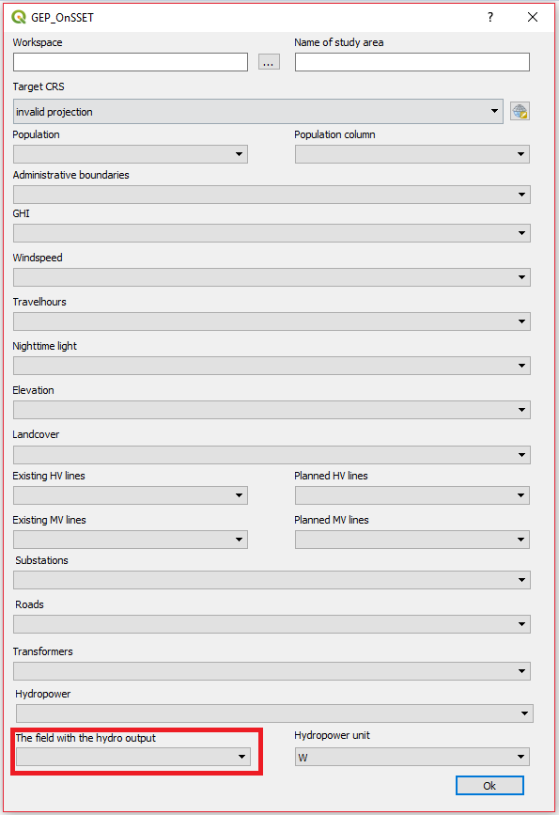

Figure 18. Field in the attribute table that includes the hydropower potential

**Box 23.**  Select the unit of that the hydropower output is given in. You get to choose between W, kW and MW.

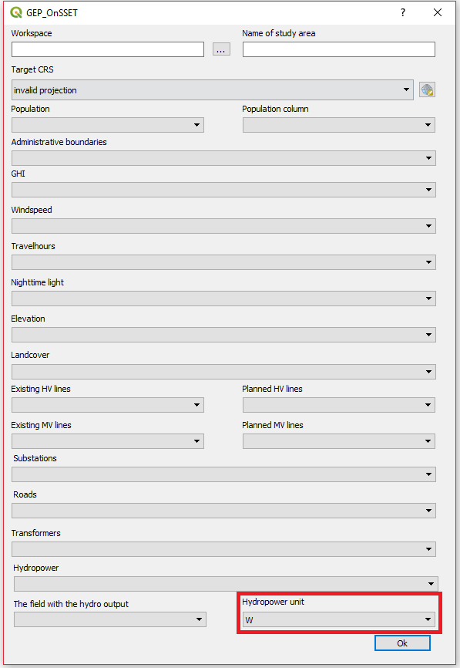

Figure 19. The unit of the values in Box 18

1. When all boxes have the correct data click “OK”. This will run the plugin. Depending on the size of the country this can take between 5 minutes and a number of hours.

**Note:** While the plugin is running you will not be able to use QGIS. If you try to use QGIS you will get a loading icon. When the loading icon disappears the process is finished.